**Project Name: Efficient Shipping Management System**

**Project Members:**

**Darshana Agarwal 210943120009**

**Saurabh Jagadale 210943120034**

**Kshitij Ghogare 210943120043**

**Introduction of Project:**

The “**Efficient Shipping System**” is online marketplace which provides platform for customer to connect with many transporters within a click. This saves customer’s time as well as money. The transporter can get information of many products posted by customer’s and it is helpful to expand their business.

**Objective and Scope of Project:**

This system used for shipping purpose, where customers can connect directly to the transporters. Once customer puts their item details on site then they can directly connect with many transporters who are ready to ship their material/item. This system is customer friendly and affordable. This system will create virtual competition between transporters which will benefit the end user.

**Modification and improvement over the existing Implementation:**

**Present State:**

Some transporter has their own online platform for shipment, some of them don’t have it also. Transporters who has their online platform, they are having their **fixed rates**. So that **customers cannot manipulate** them in rates.

They provide **date of delivery** by their **convenience**, here also customers cannot manipulate. For getting better rates customer have to visit many individual platforms of transporters. Its **time consuming** for customer.

**Those transporters who has not their online platform**-

Customer has to **reach them physically** which is also **time consuming.**

**After implementation of project:**

Our platform is going to be used by Customer and Transporter both. Customer can put their product for shipment on our platform and that **request is sent at a time to all the** **transporters who have registered**. Customers don’t need to go anywhere physically. Customer can put Pickup Date, Delivery Date, Price range while putting that item on the platform. Transporter will give update to this request by putting their rate and delivery date. Some of them are shown to customer. Customer will select any transporter who has responded to that request. After this process, contact information of customer and transporter will get exchanged. So that **Security** is also maintained.

**This is single platform for customers and different transporters.**

**Customer doesn’t need search for various individual platforms.**

**Customers doesn’t need to go physically anywhere.**

**Here both customer and transporter tasks becomes easy.**

**Security is maintained here.**

1. **Hardware and Software Requirements (Minimum):**

**Hardware:**

1. Intel i3 processor 3rd generation or later / AMD Ryzen 200 2nd generation or later

2. 4 GB ram.

3. Windows 7 Home edition or later.

4. 200 GB Sata HDD Space

5. Data Connection 200 kbps

**Software:**

1. Eclipse 4.7
2. MySQL 5.7 with Workbench 8.0
3. Google Chrome version 79.0
4. Apache Tomcat Server 8.5
5. Maven Dependencies
6. Visual Studio
7. **ER Diagram:**

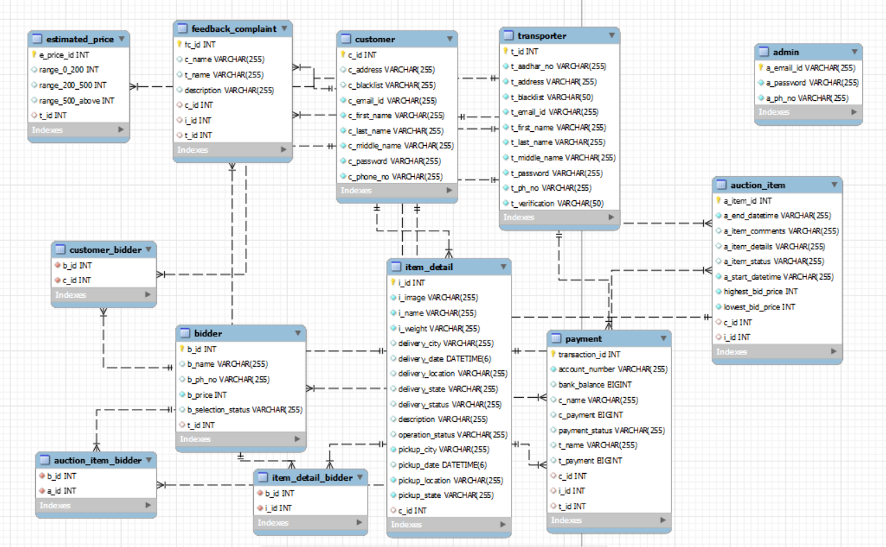

Figure 1: ER Diagram

1. **Table Structures:**

* Admin Table:

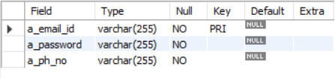

* Customer Table:

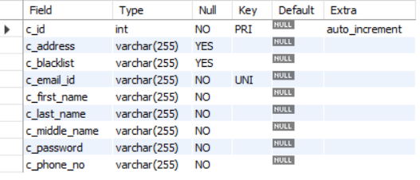

* Transporter Table:

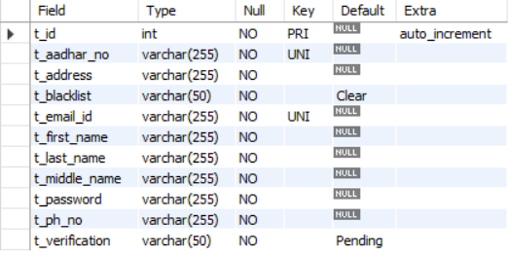

* Bidder Table:

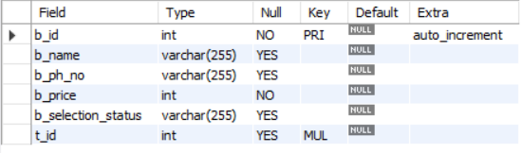

* Item_Detail Table:

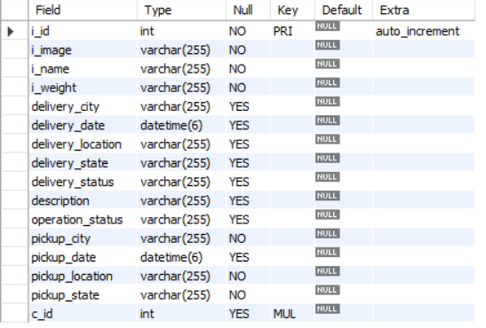

* Auction_Item_Detail Table:

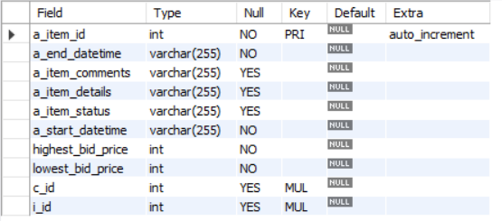

* Estimated_Price Table:

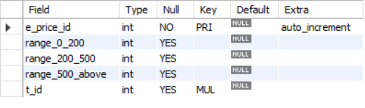

* Payment Table:

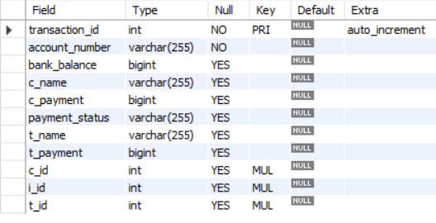

* Feedback_Complaint Table:

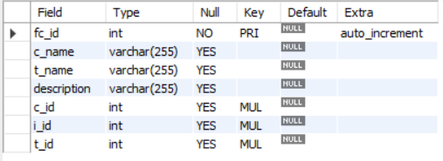

DATA FLOW DIAGRAM:

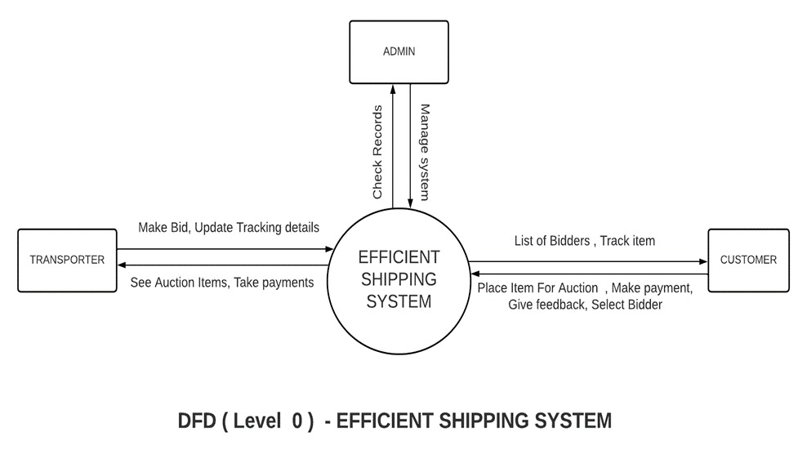

1. **End to End Flow of Application:**

**Project Plan:**

No. of User’s and Modules

* **Users-** No. of user’s :3 (Admin, Customer, Transporter)

ADMIN:

1. Document verification of Transporters when they register.
2. Edit/Remove transporters as well as customer or put them in **blacklist** if any undesirable things happens.
3. Check and manage the feedback, complaints of users and transporters.
4. Manage the commission payment done by transporter.

TRANSPORTER:

1. Register/Login to the system
2. Check items / products posted by user.
3. Set Bid for the particular item/product.
4. Update the bid before Bid time close.
5. Set Delivery and Pickup date (when transporter can deliver the product and Pickup the product).
6. Verify the product before shipping.

CUSTOMER:

1. Register / login to the System
2. Add /Update product details (such as pickup date, delivery date, bidding time, lowest bid price, highest bid price, pickup location, delivery location etc.)
3. Customer can book their item directly to particular transporter. (In project -DIRECT BOOKING)
4. Customer can put their item for auction (In project -GO FOR AUCTION)
5. Select any one transporter who has given bid.
6. Select particular transporter for their shipment directly.
7. Give feedback /complaints.

**Modules** -

1.Login and Registration module

2.Direct Booking Module

3.Auction Module

4.Payment Module

5.Feedback Module

**Future Scope:**

1. Expand the scope of the system overseas.
2. Advanced tracking system
3. Message and Email alerts for various happenings can be added to the system so that transporters do not miss the updates.
4. The software is flexible enough to be modified and implemented as per future requirements.
5. While adding the product details customer can use filter.

(for ex. In filtering option, by selecting the number of successful deliveries more than 50 and feedback having more than 4 stars, So request will be visible to only filtered transporters only )

1. Insurance system
2. Tracking system

**Screenshot’s:**

1. **Home Page:**

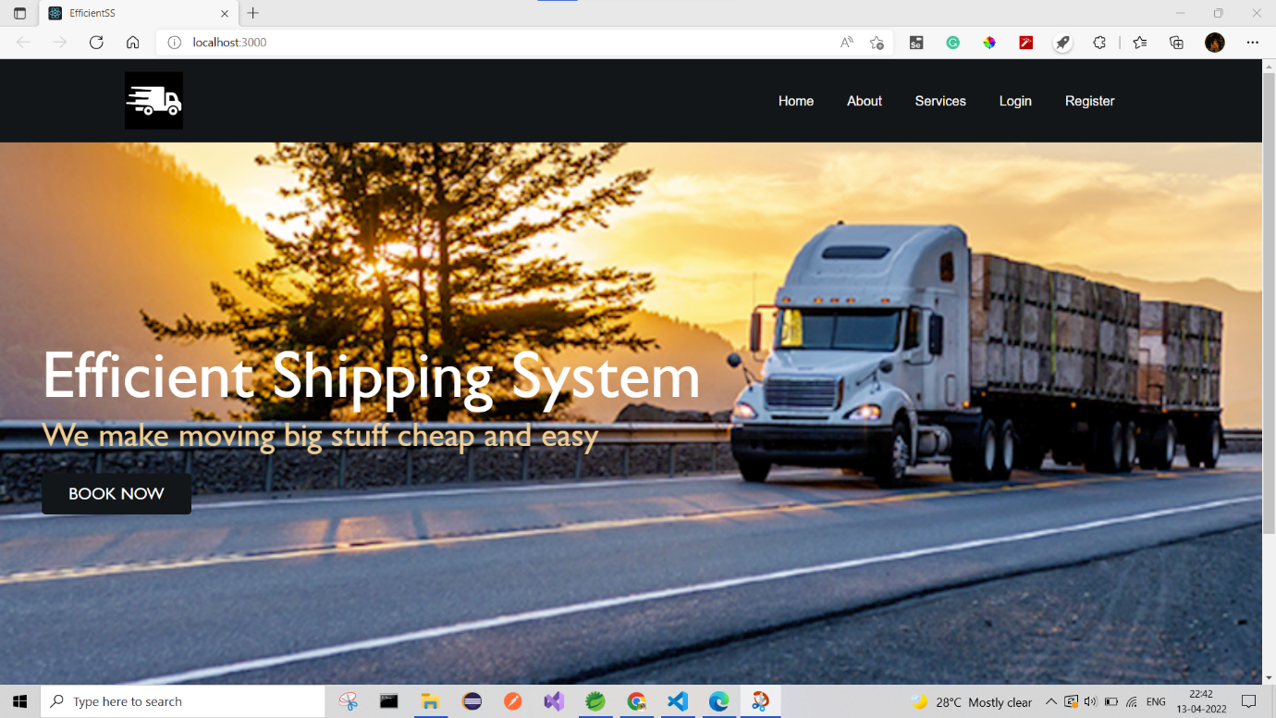

1. **Services:**

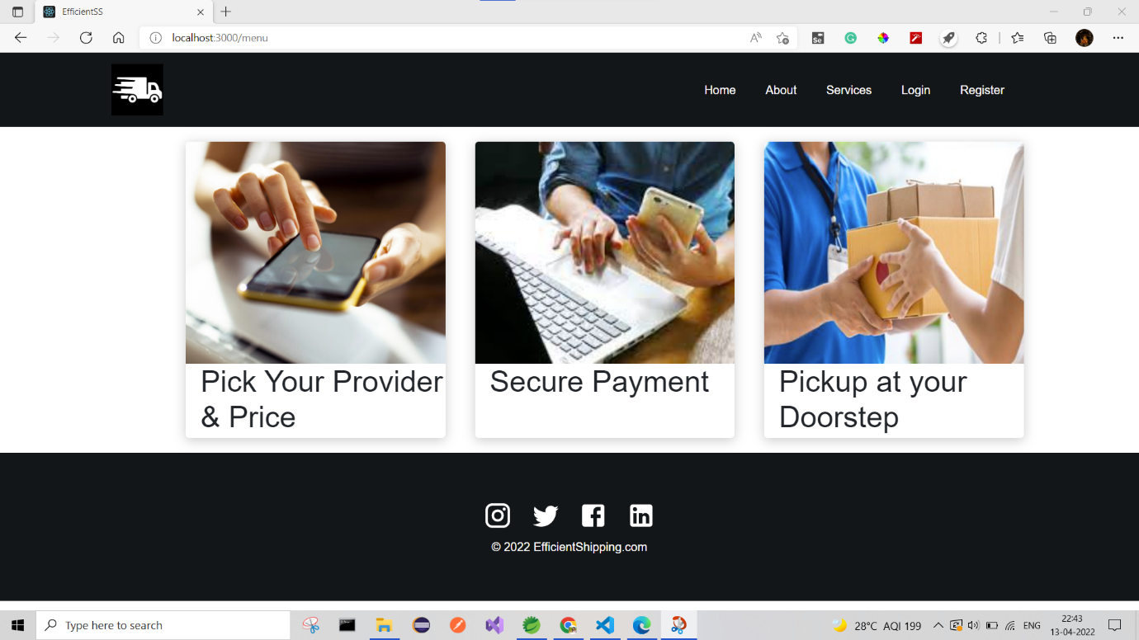

1. Registeration:

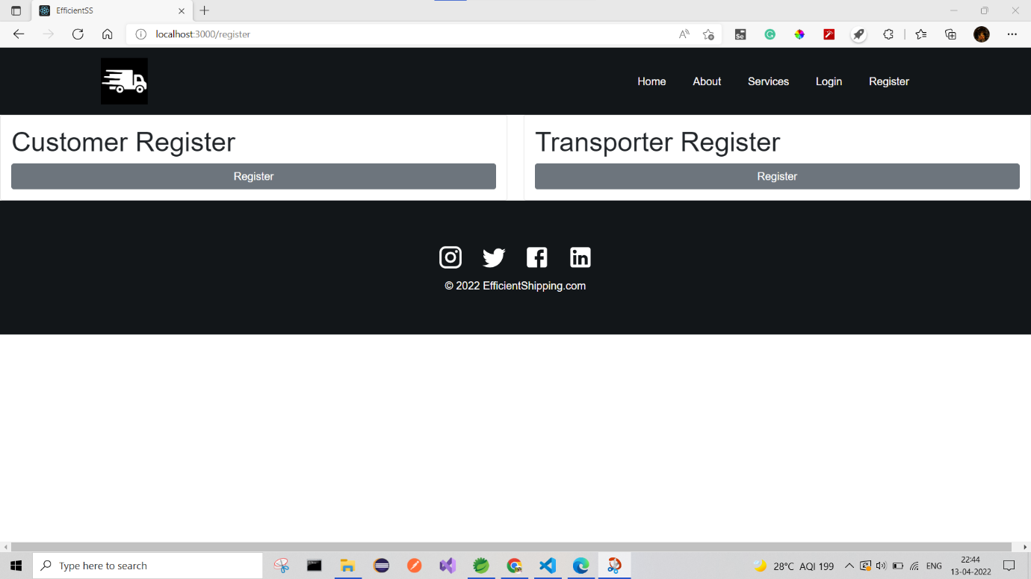

1. Customer Register:

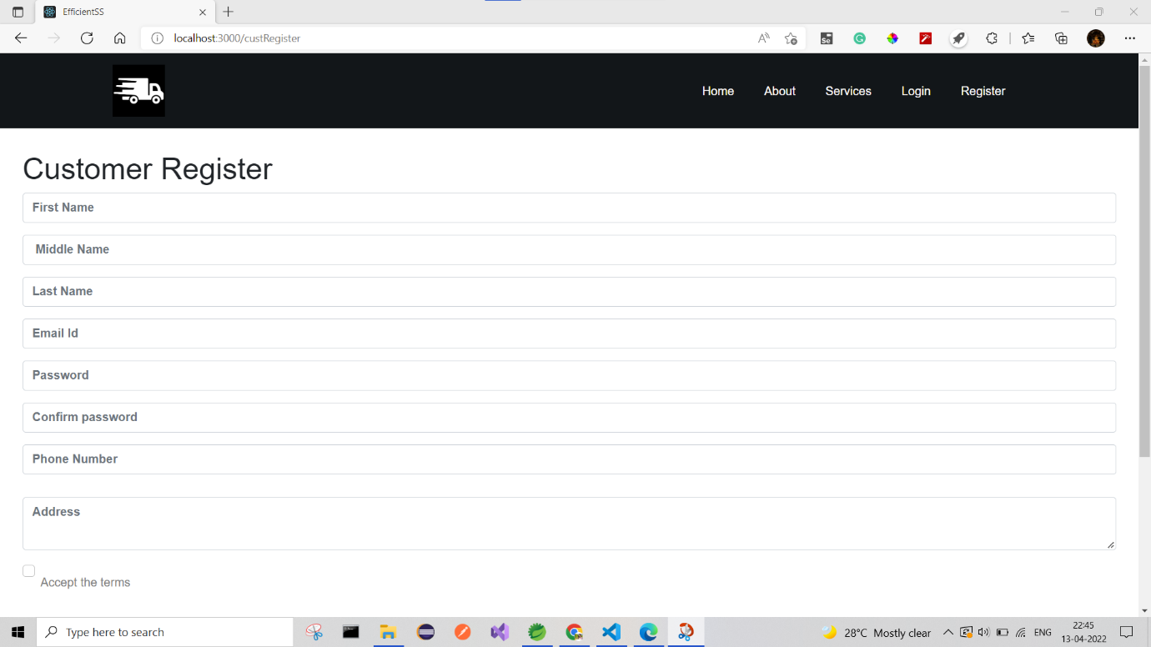

1. Transporter Register

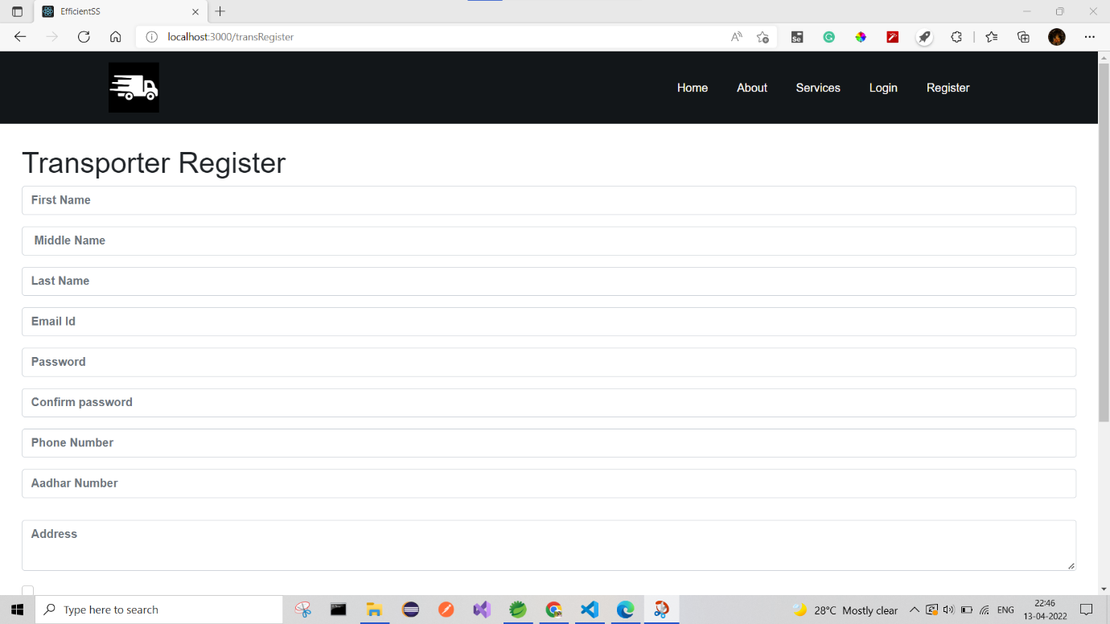

1. Login Page:

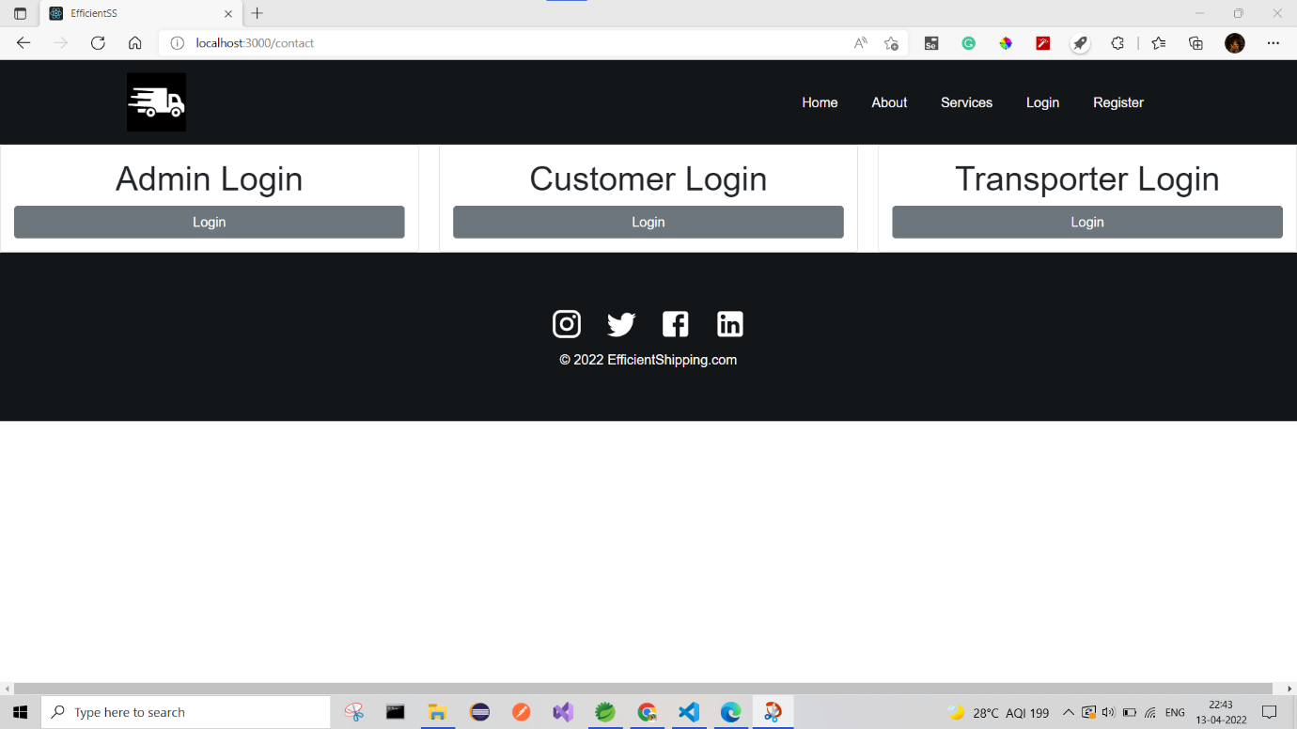

1. Admin Login

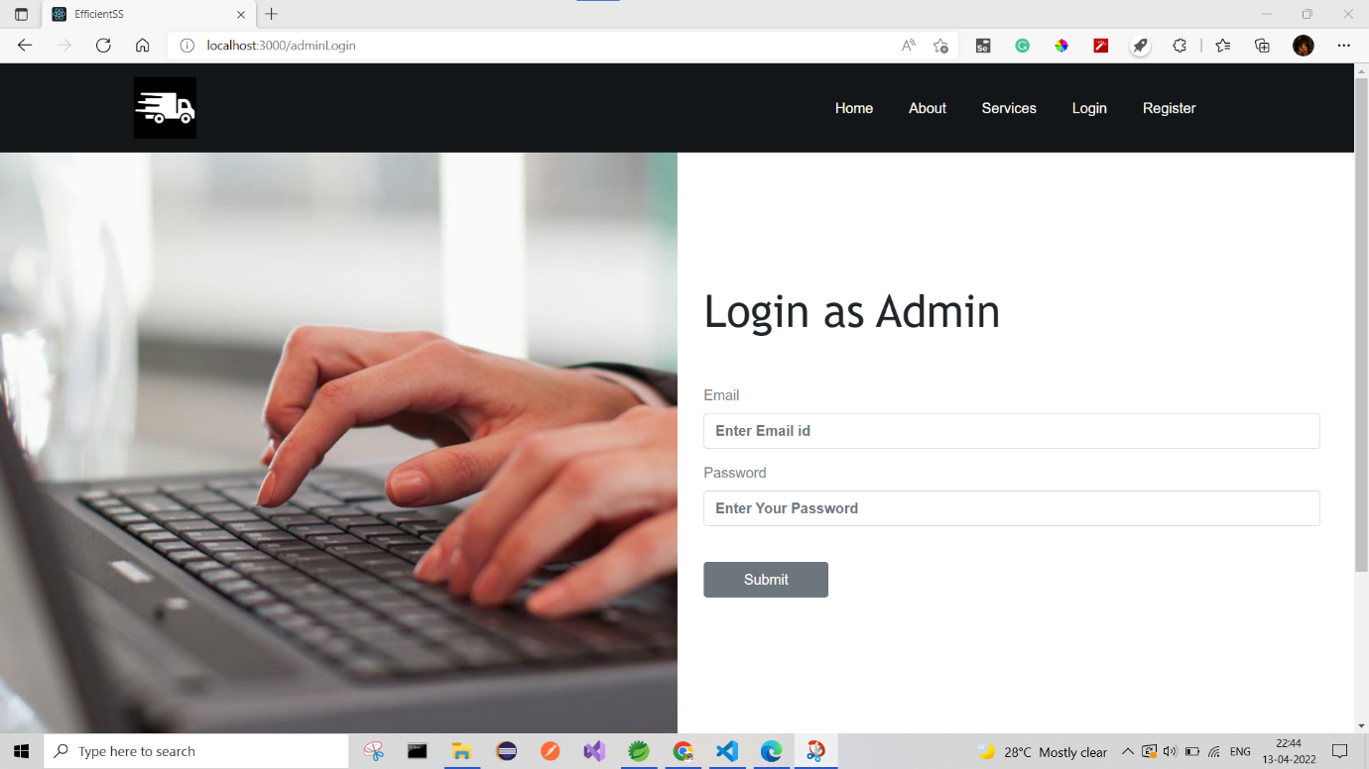

1. Customer Login

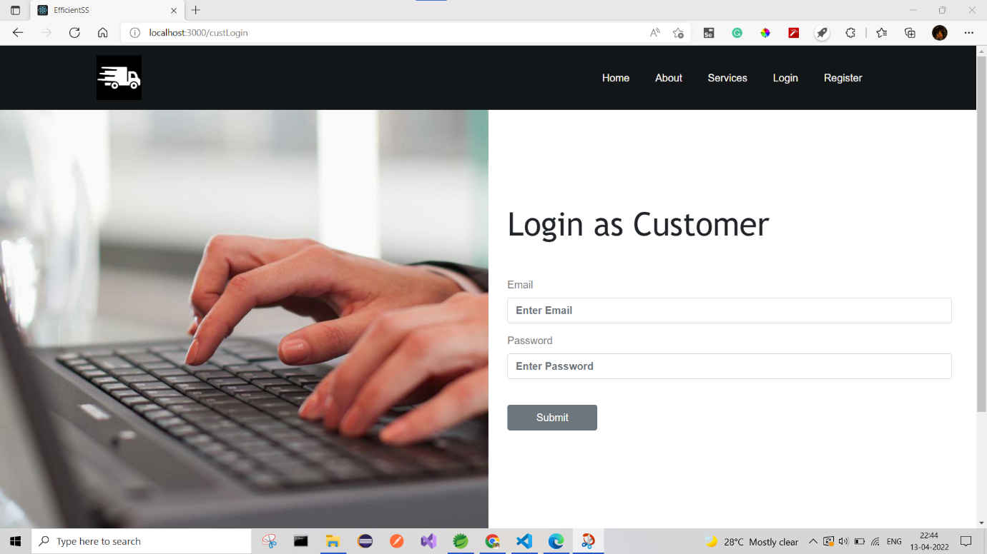

1. Transporter Login

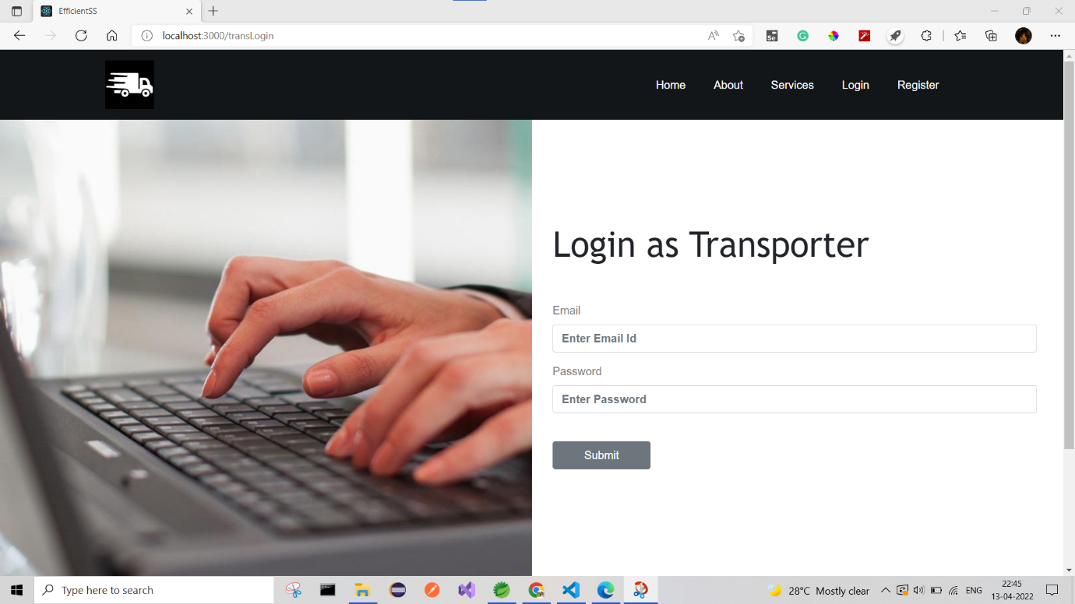

Admin Dashboard:

1. Manage Customers:

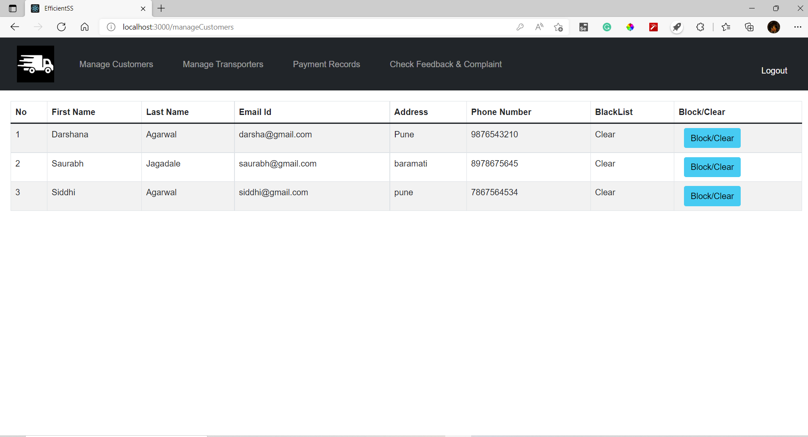

1. Manage transporters:

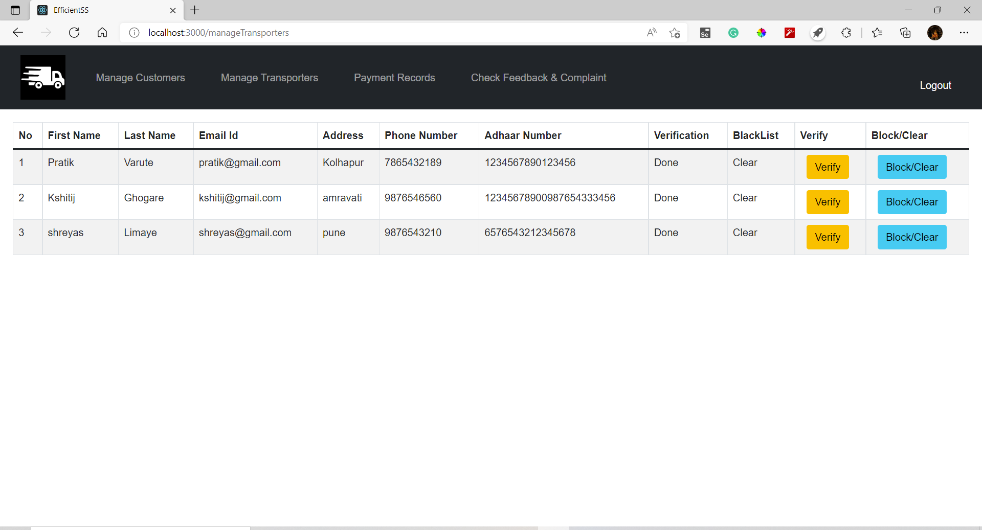

1. Check Payments:

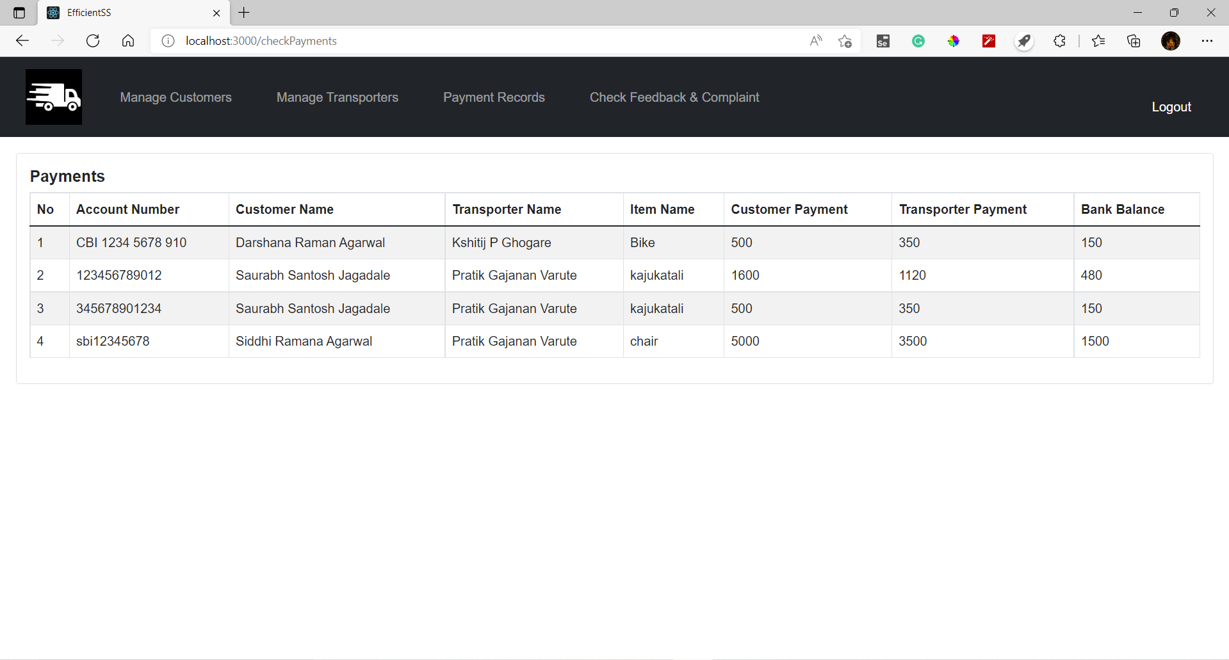

1. Check feedback and Complaints:

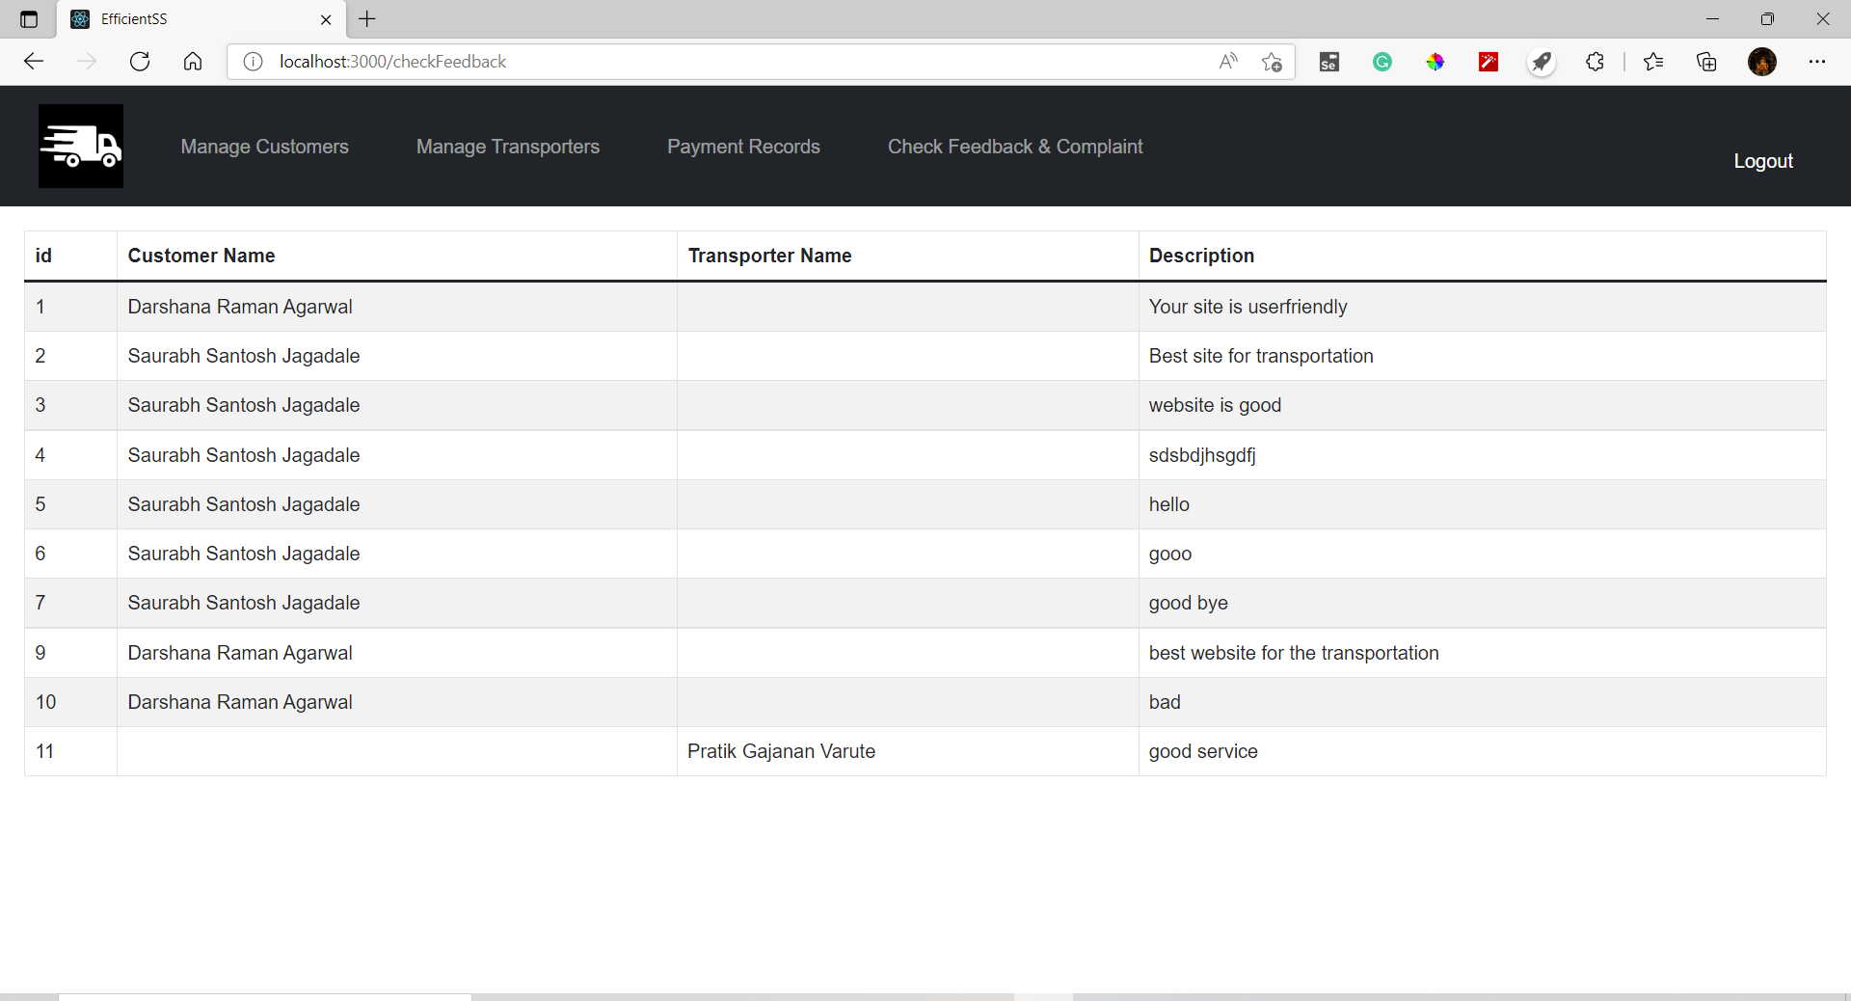

Customer Dashboard:

1. Register Items:

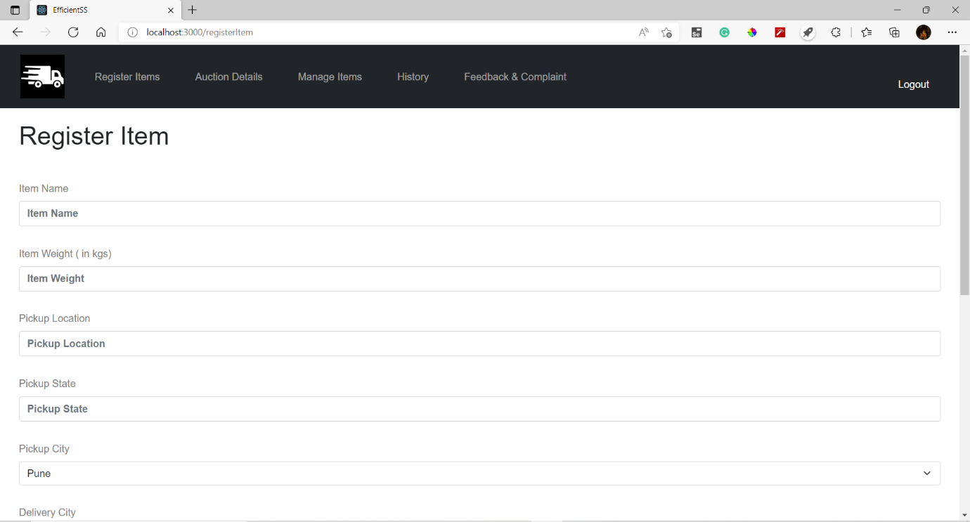

1. Manage Items:

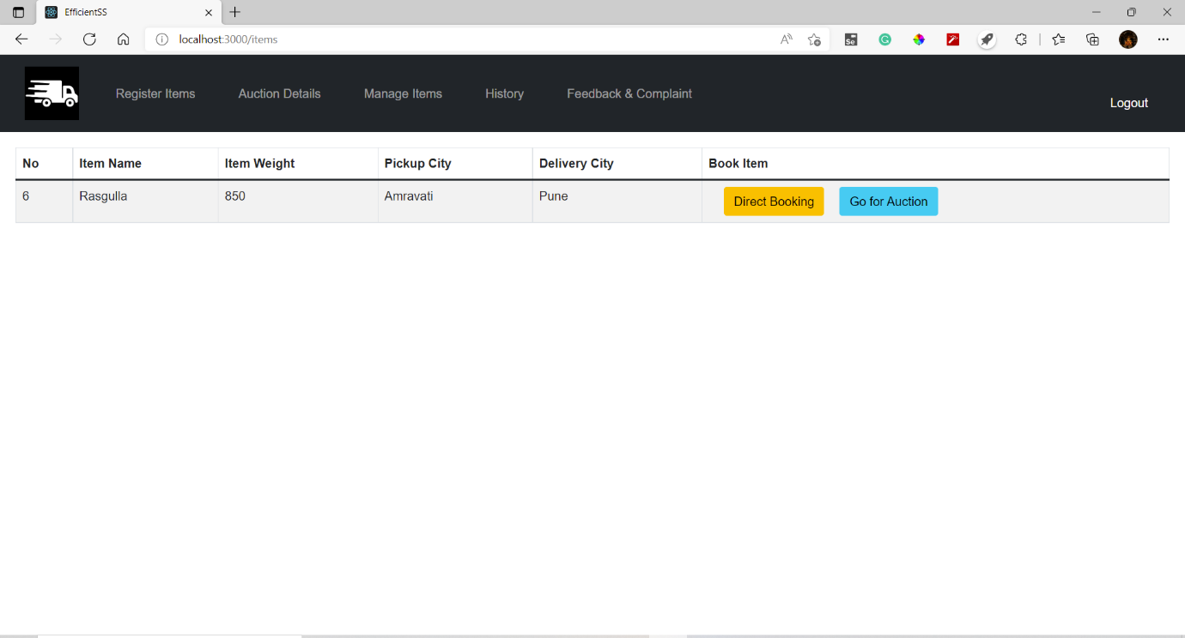

1. Direct Booking

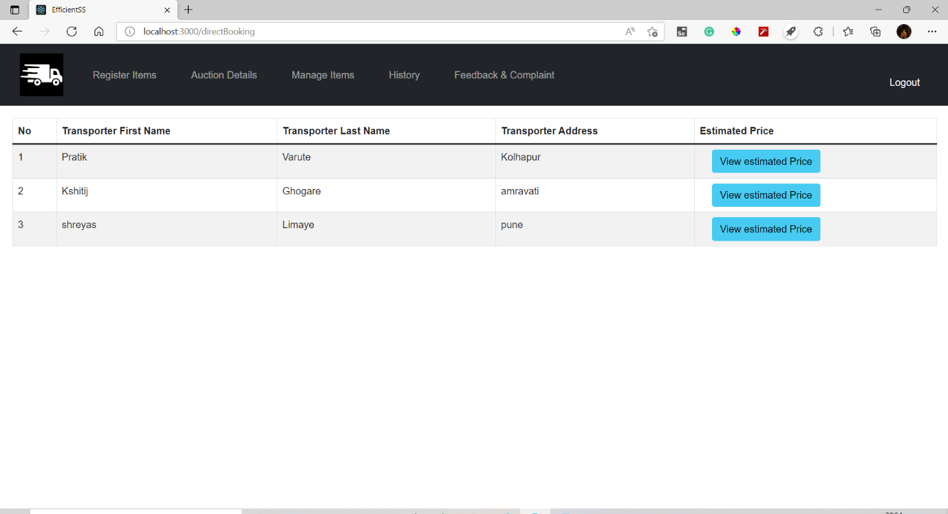

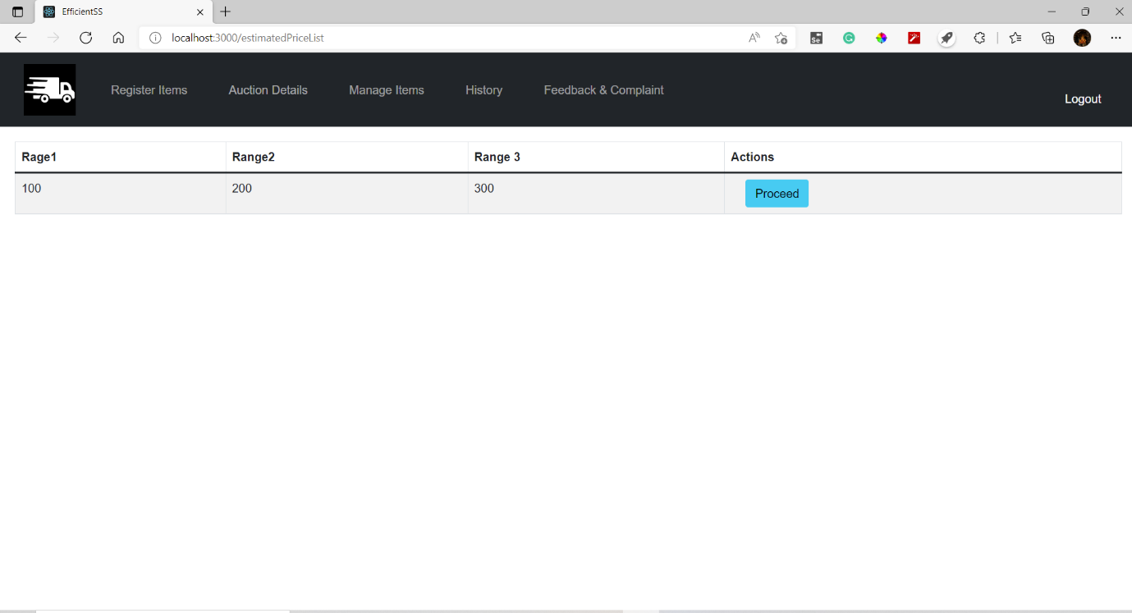

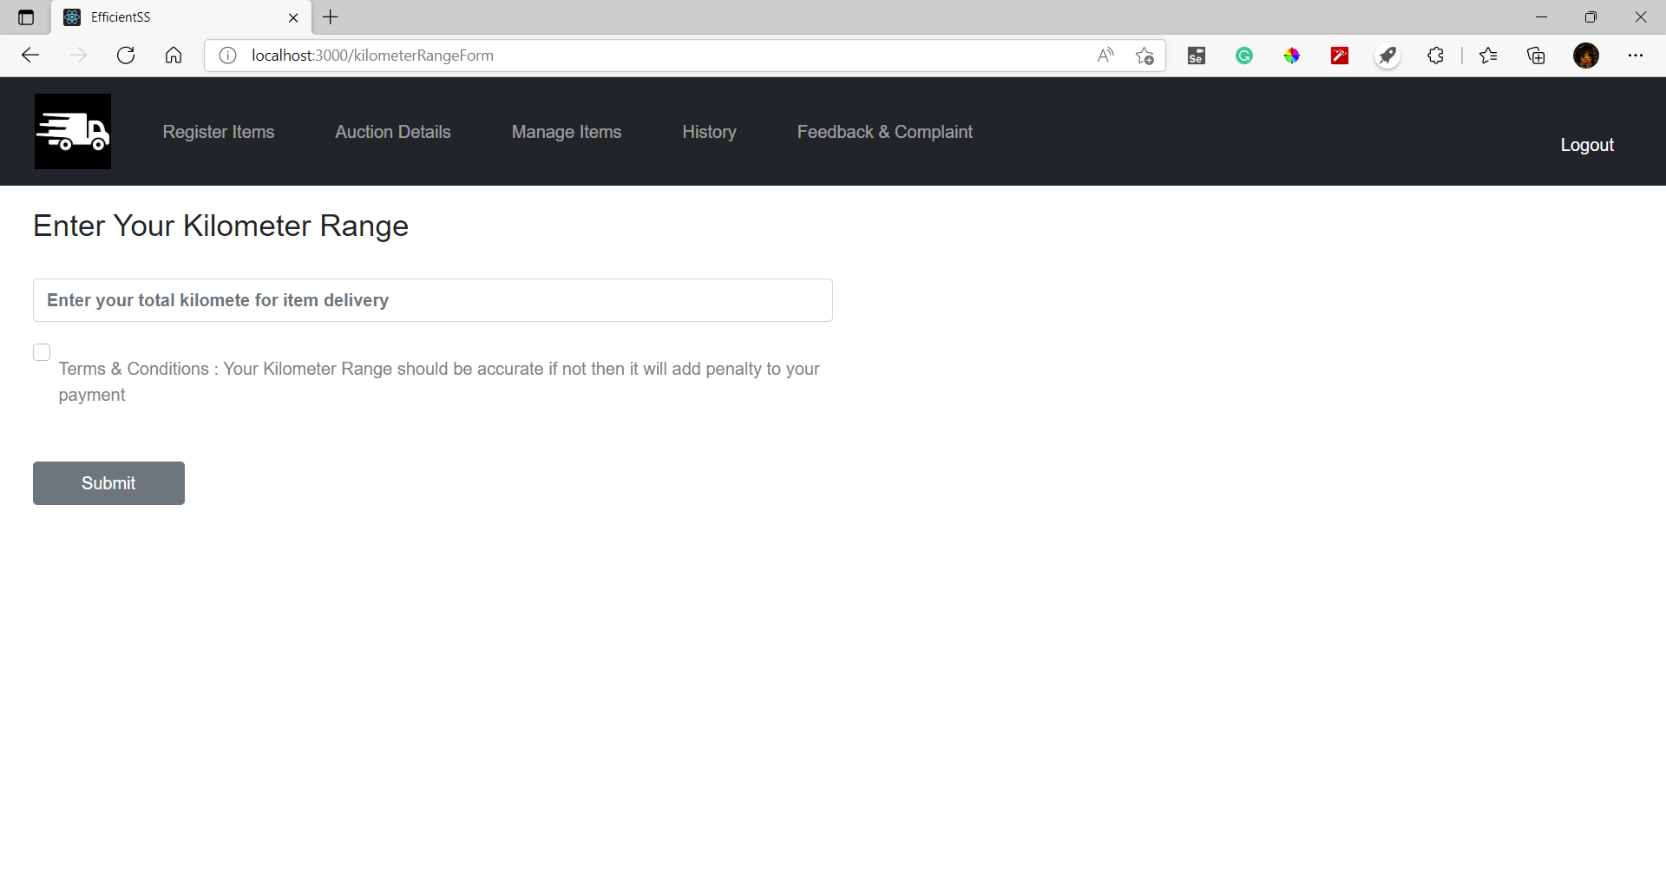

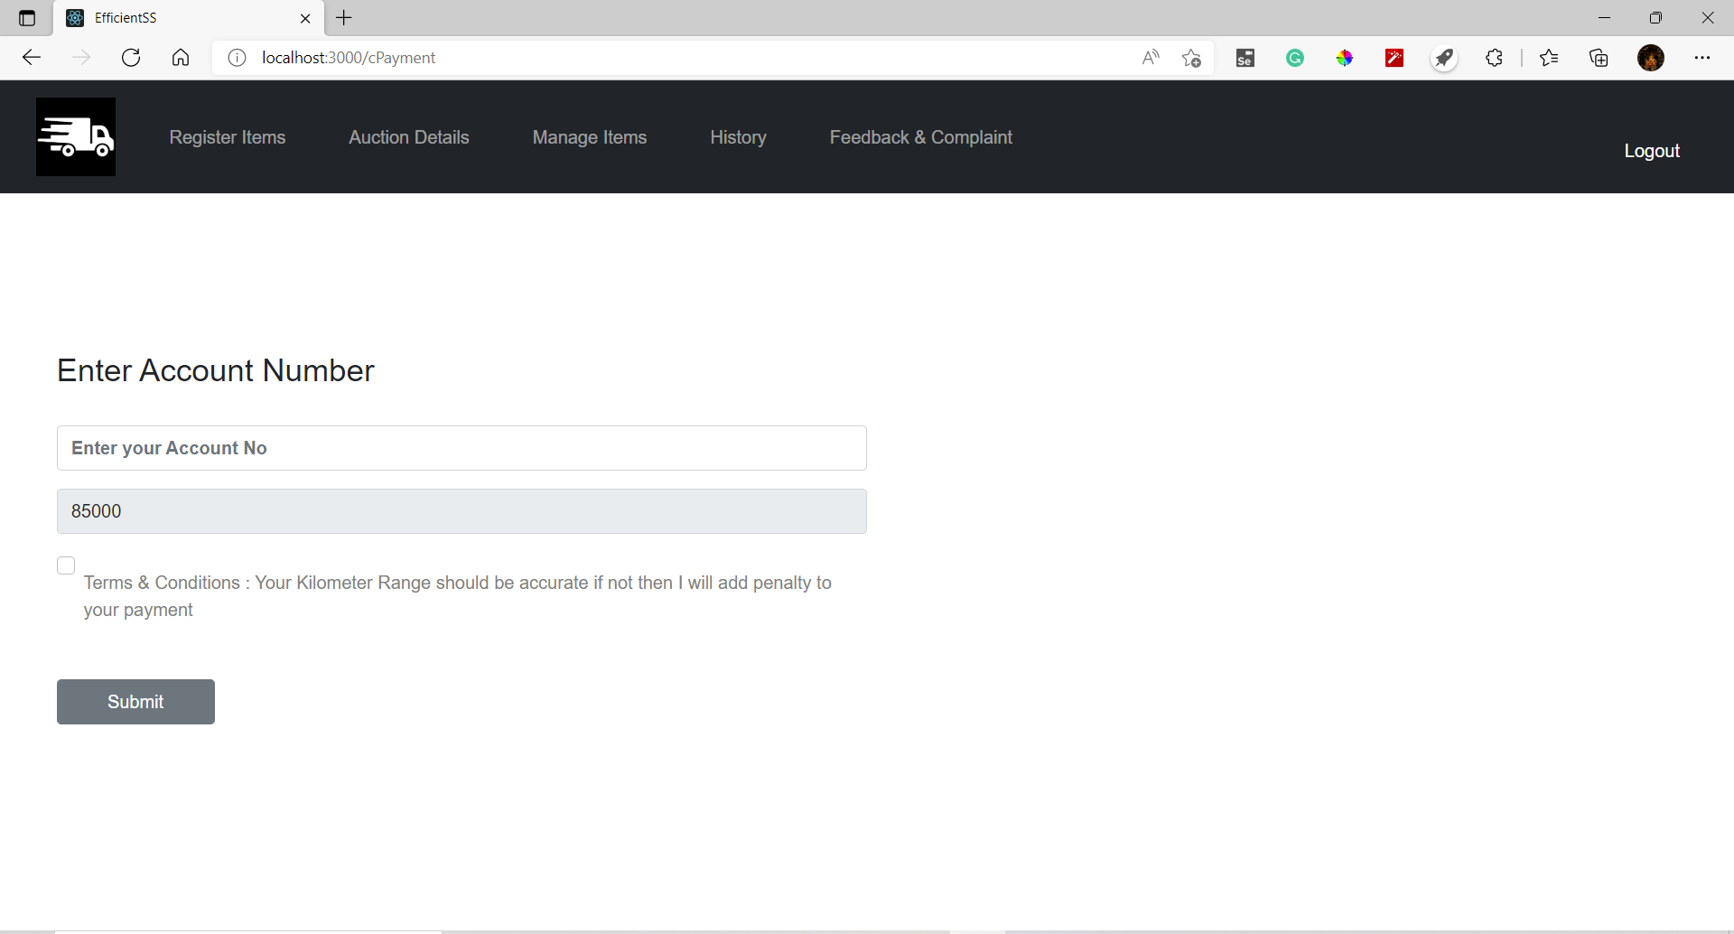

1. Auction Items:

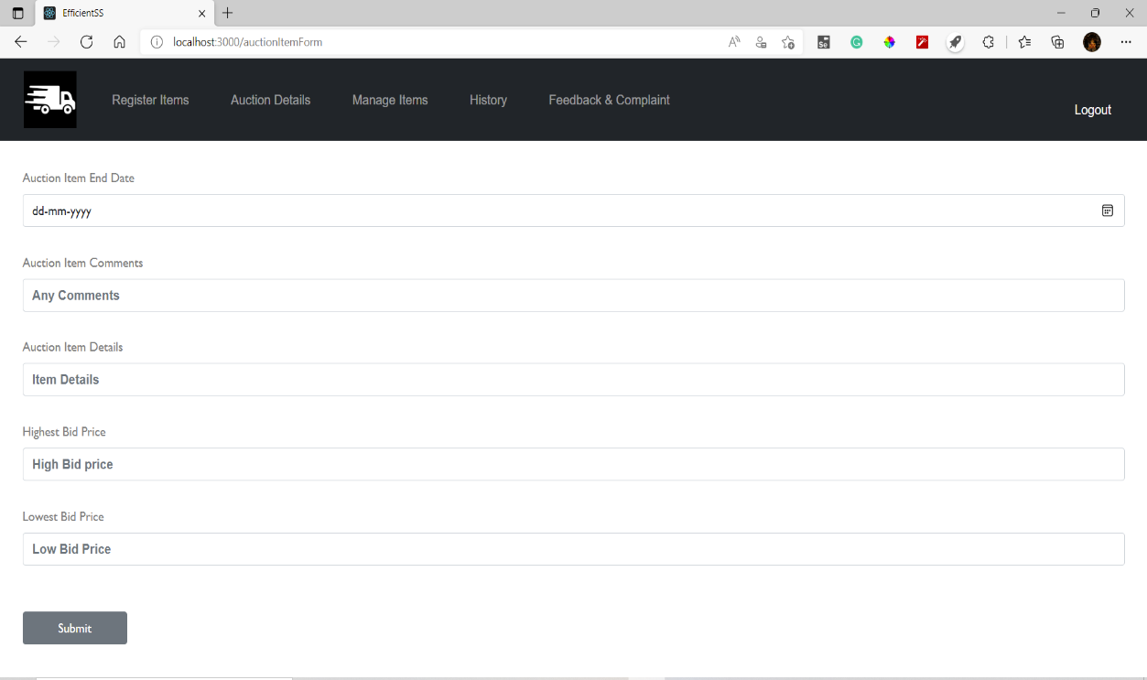

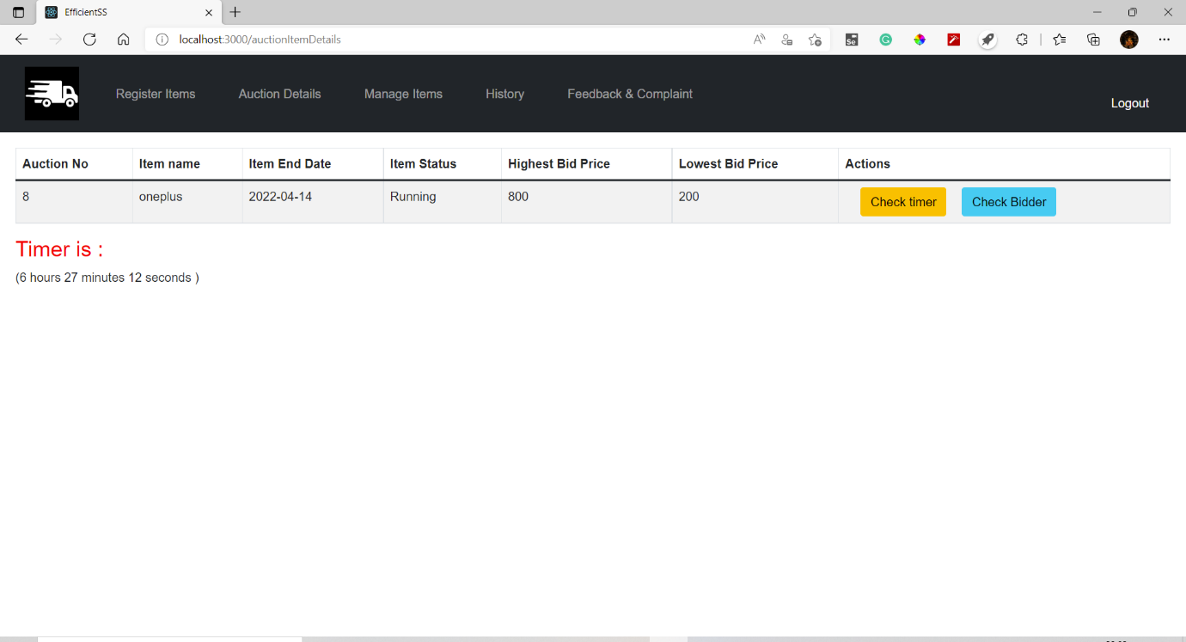

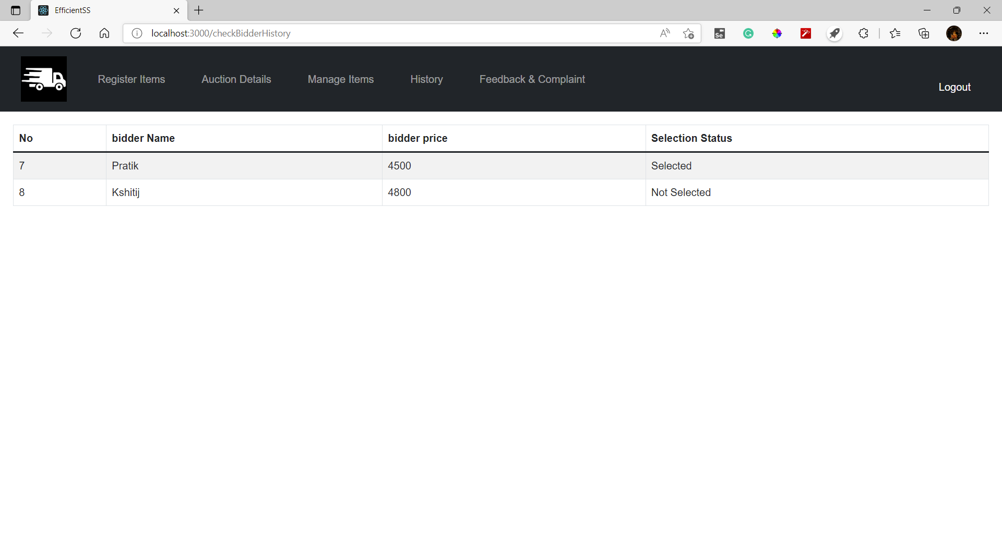



1. FeedBack:

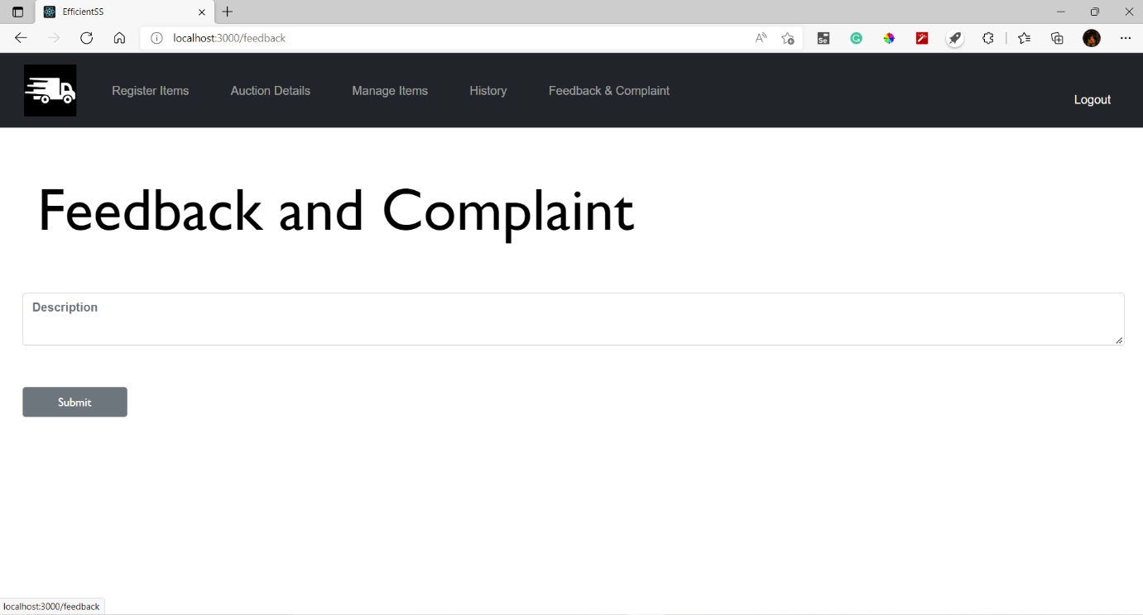

1. History:

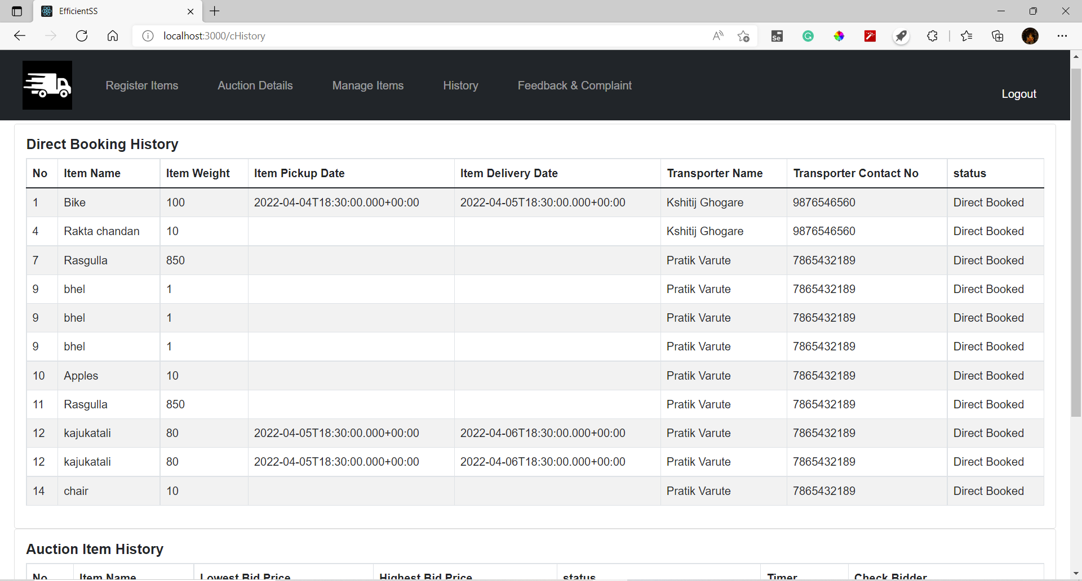

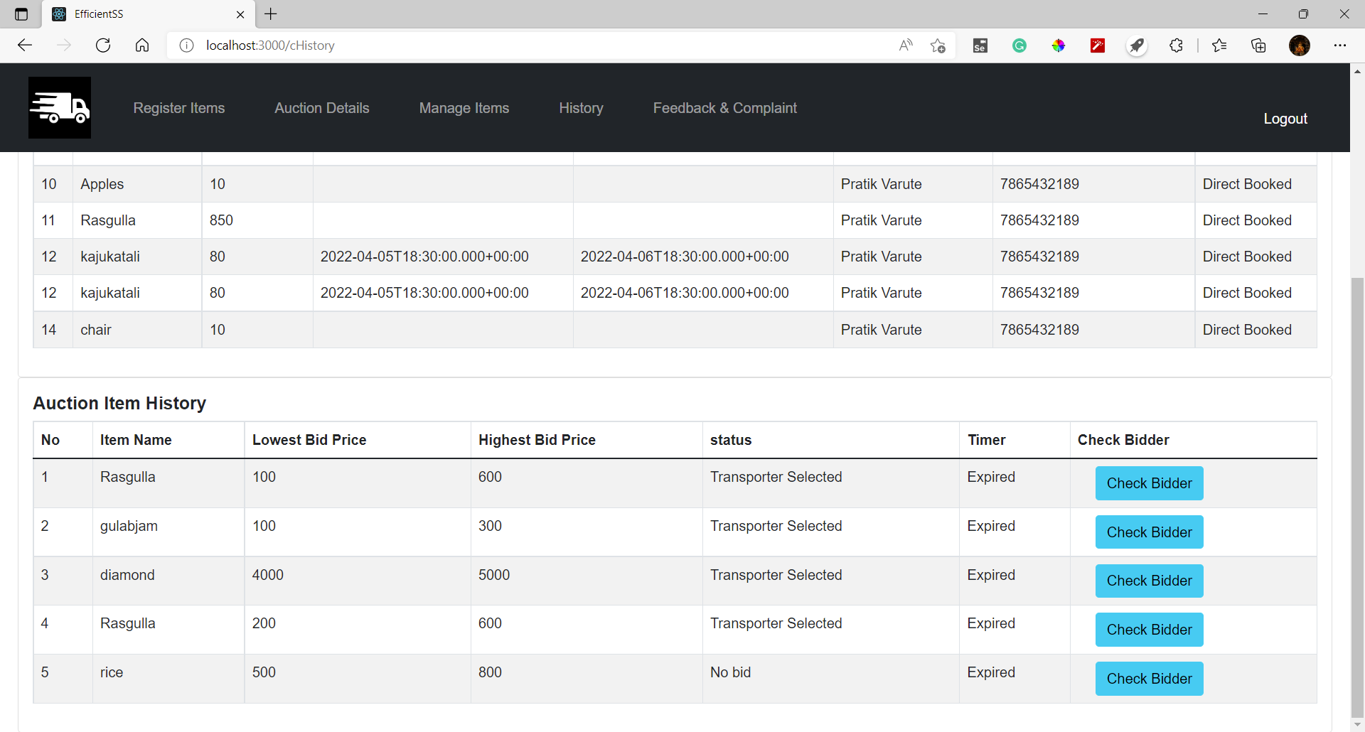

Transporter Dashboard:

1. Estimated Price:

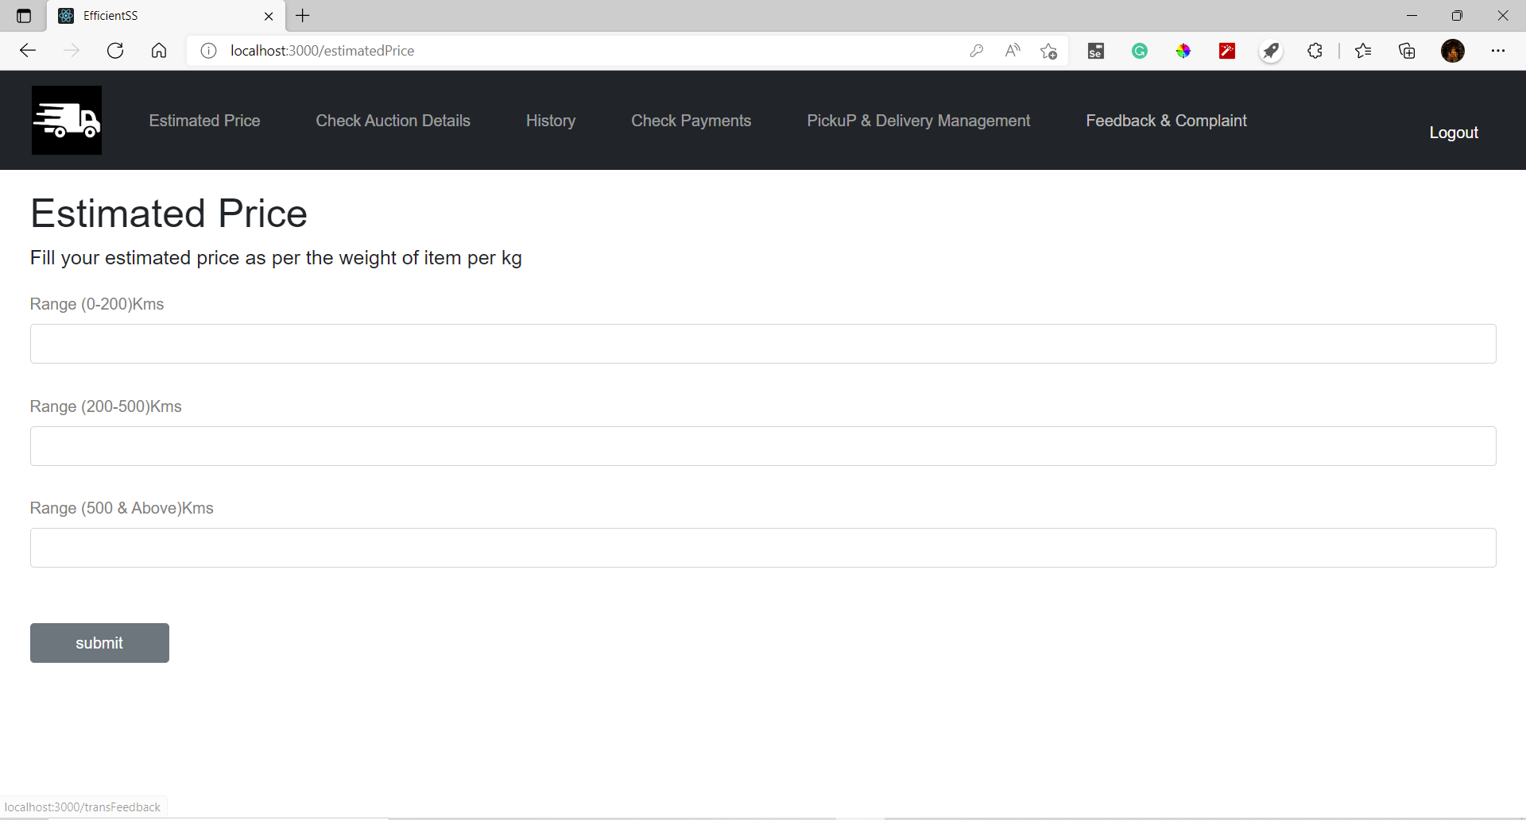

1. Check Auction Items:

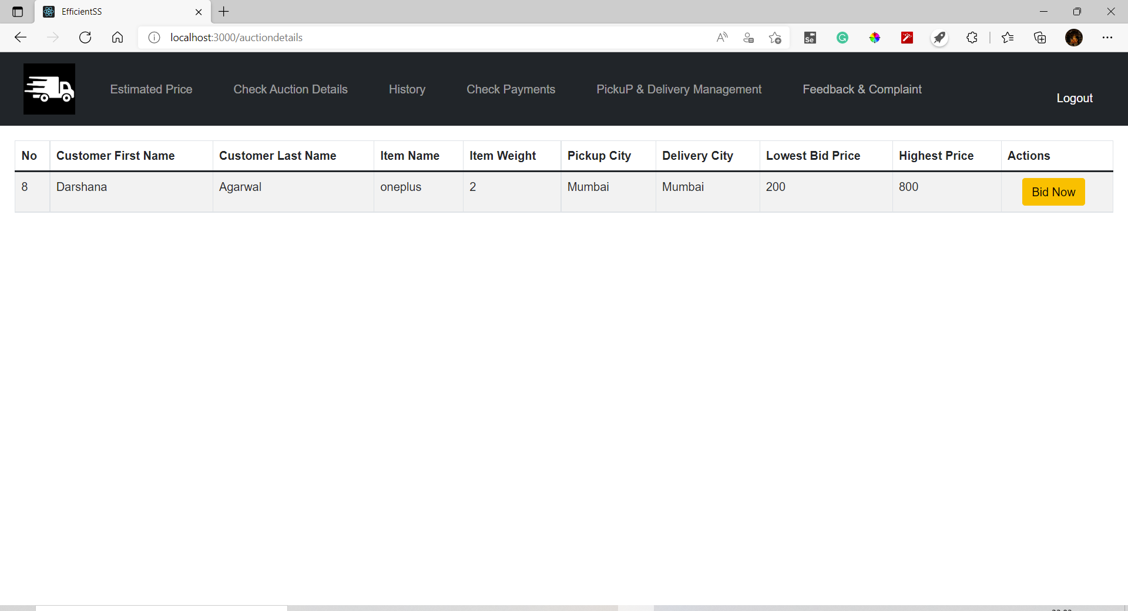

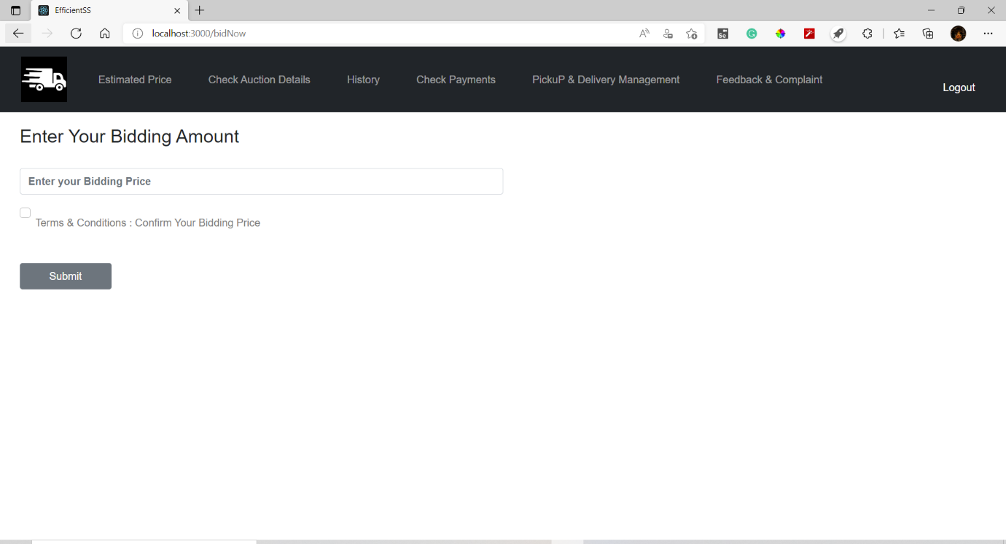

1. History:

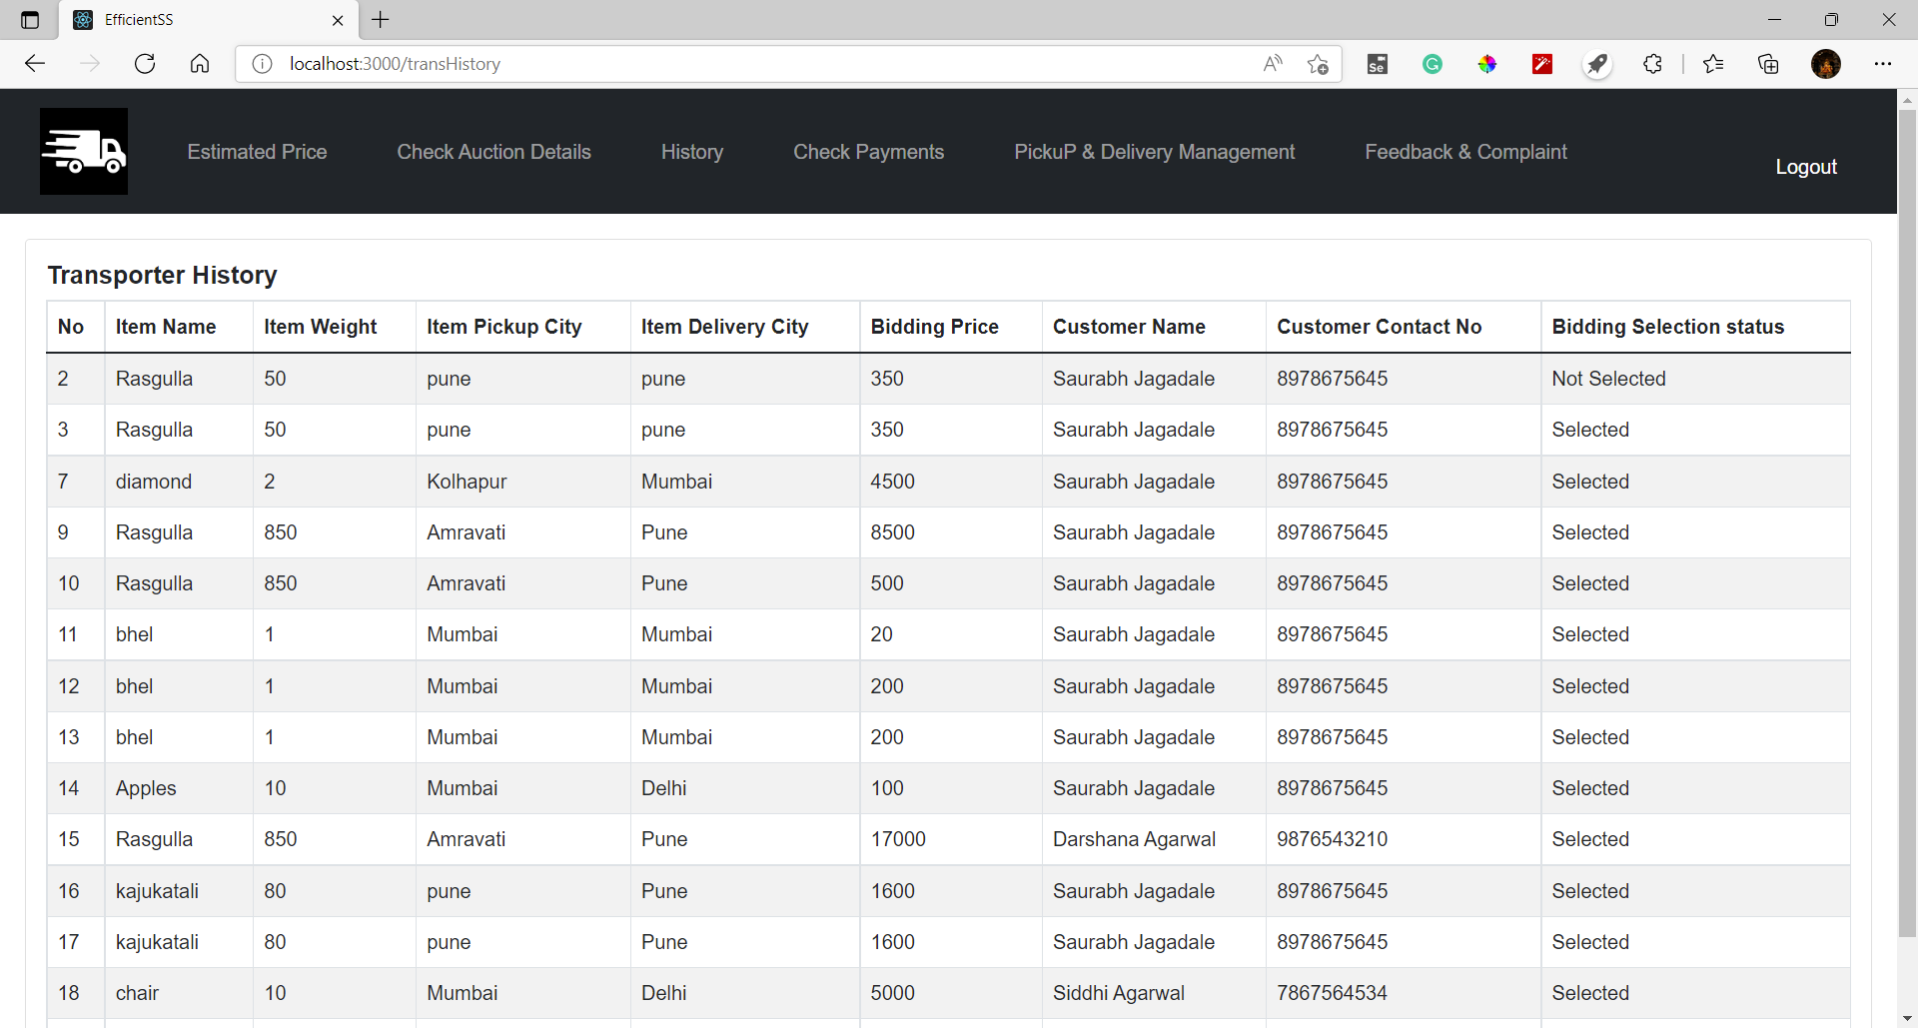

1. Pickup and Delivery Status:

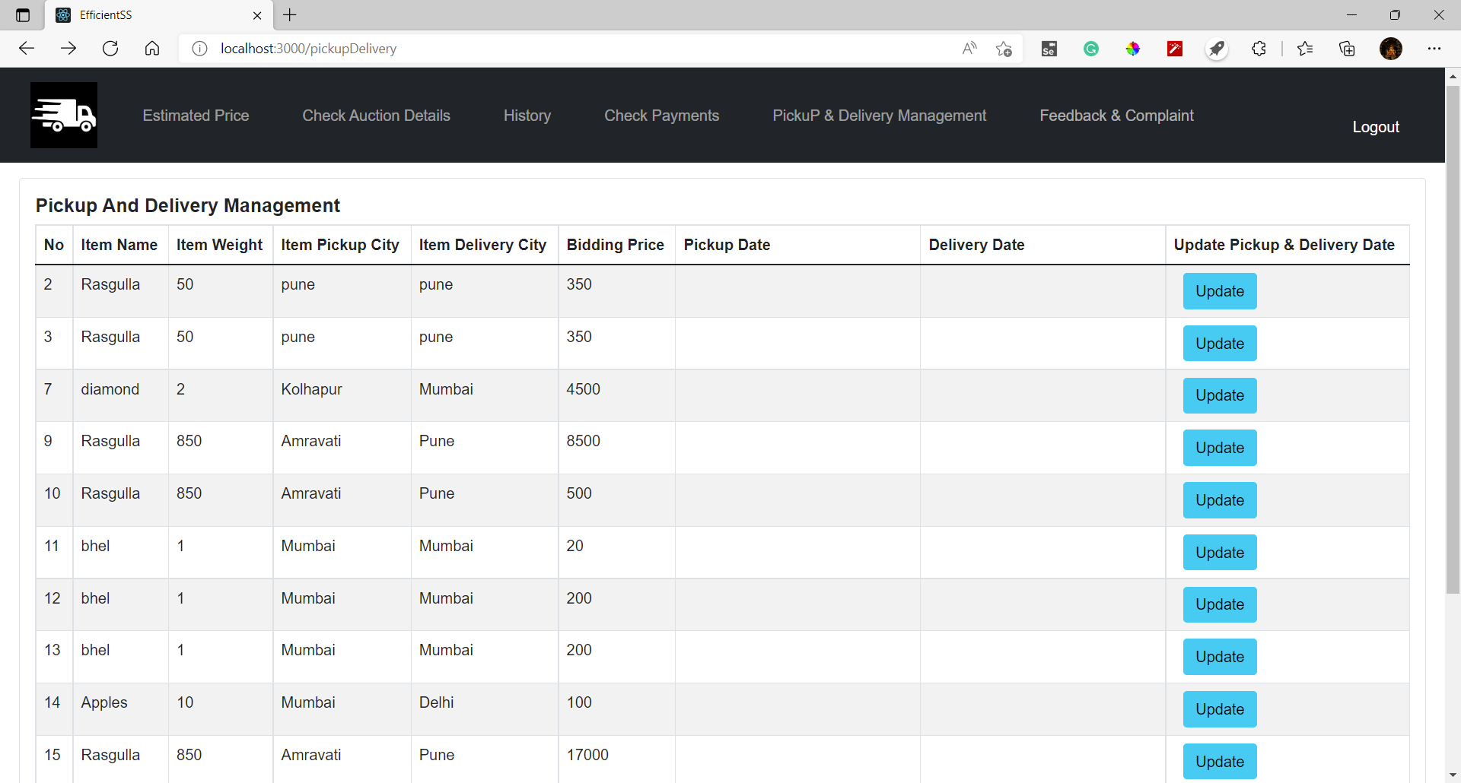

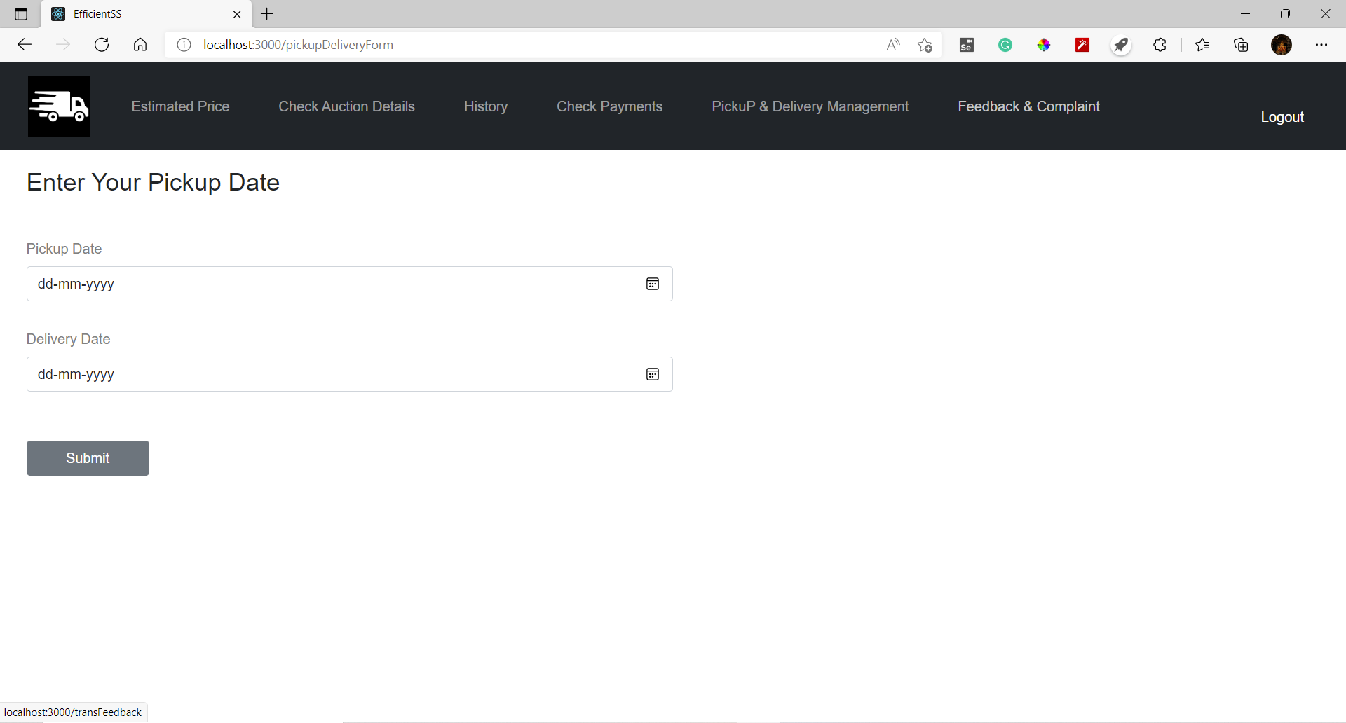

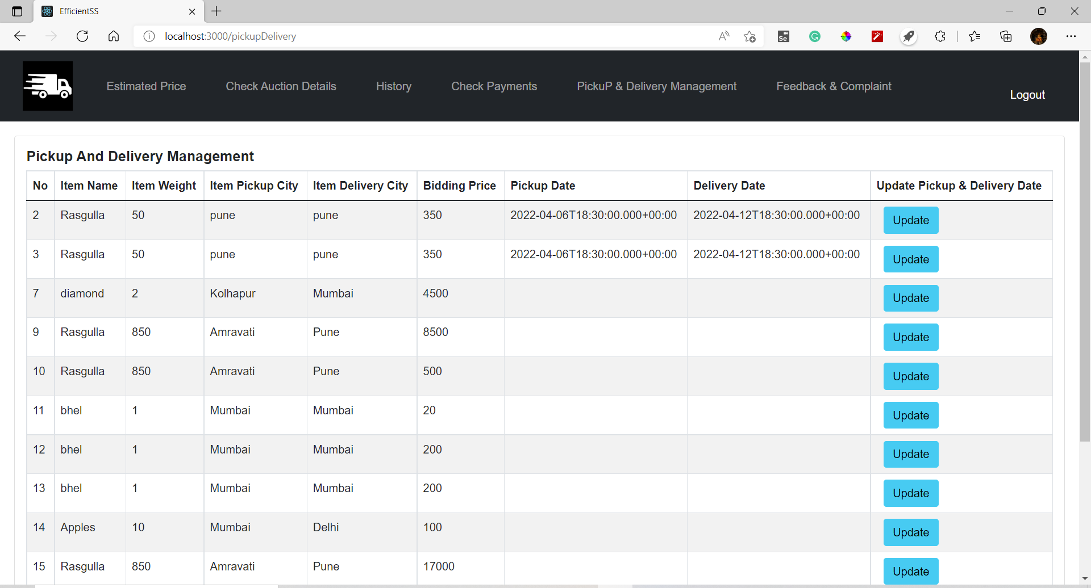

1. Check Payments:

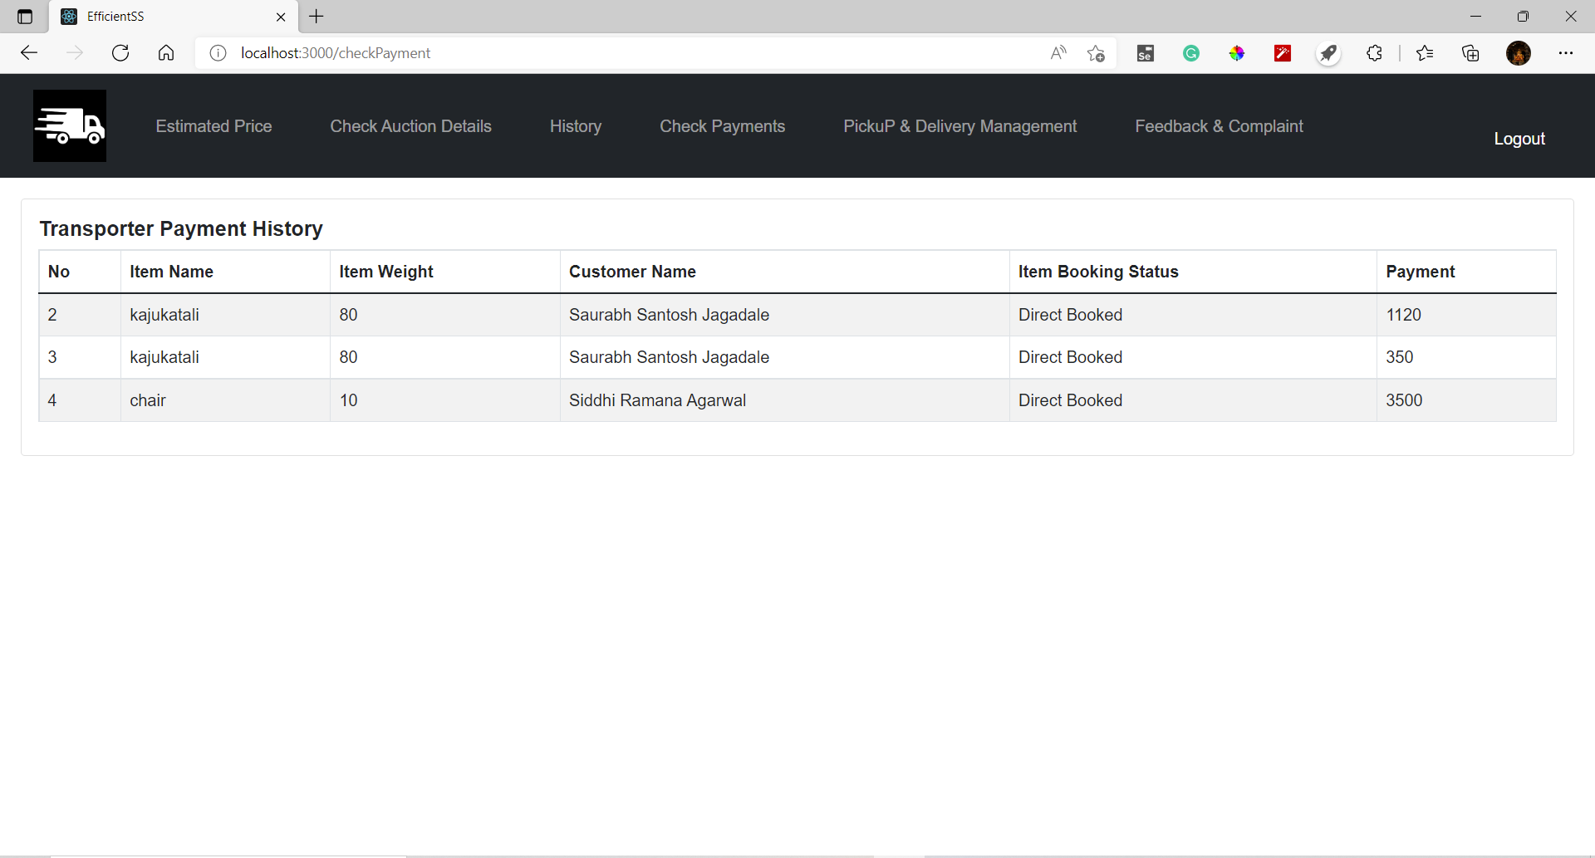

1. Feedback and Complaint:



**Thank You!**